Network Cable and connectors Pending
Network Cable & RJ-45 Practical – Detailed Answers
1. Cat6 Ethernet Cable – T568B Wiring Diagram
A Cat6 Ethernet cable contains four twisted pairs, making a total of 8 individual wires. For a standard straight-through Ethernet cable, the T568B color arrangement is commonly used.
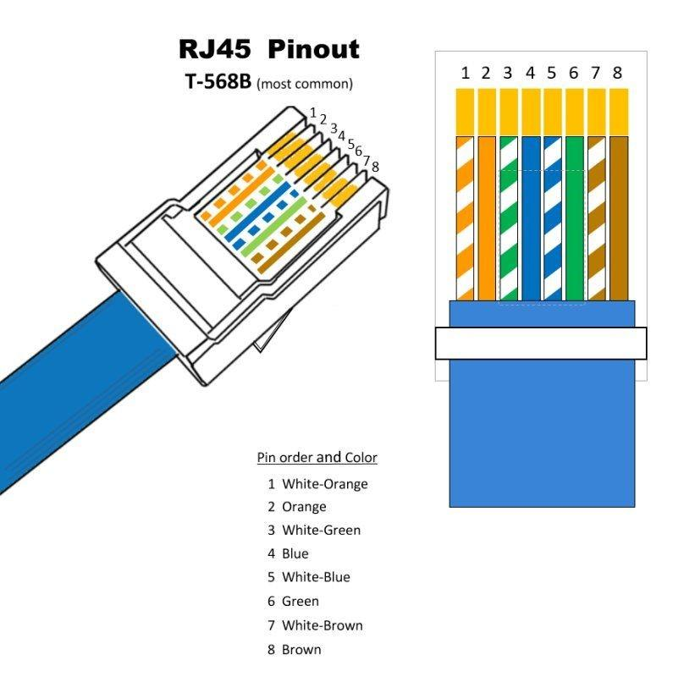
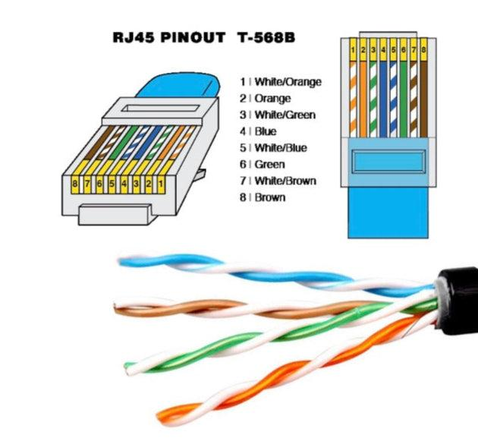
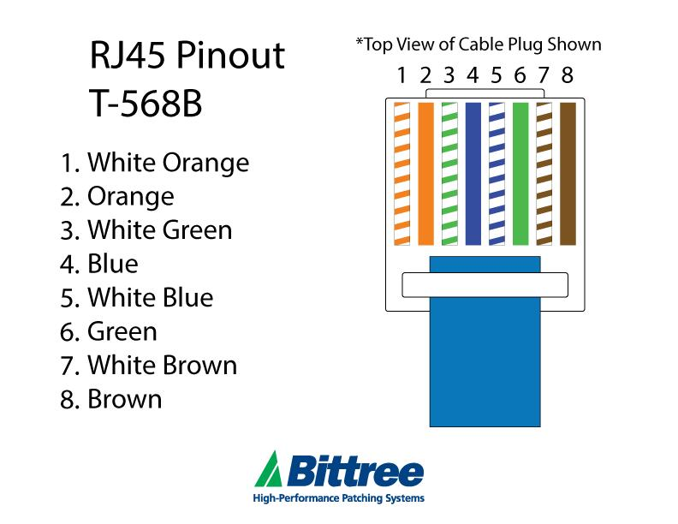
4
T568B pin order
When looking at the RJ-45 plug with the contacts facing upward and the cable entering from the rear, the wires are arranged from Pin 1 to Pin 8 as follows:
RJ-45 CONNECTOR – T568B

┌─────────────────────────┐
│ 1 2 3 4 5 6 7 8 │
│ │ │ │ │ │ │ │ │ │
│ 🟧 🟧 🟩 🟦 🟦 🟩 🟫 🟫 │
└─────────────────────────┘
│
│ Cat6 Cable
▼

Pin 1 → White/Orange
Pin 2 → Orange
Pin 3 → White/Green
Pin 4 → Blue
Pin 5 → White/Blue
Pin 6 → Green
Pin 7 → White/Brown
Pin 8 → Brown
T568B color table
Pin | Wire Color | Pair
1 | White/Orange | Orange pair
2 | Orange | Orange pair
3 | White/Green | Green pair
4 | Blue | Blue pair
5 | White/Blue | Blue pair
6 | Green | Green pair
7 | White/Brown | Brown pair
8 | Brown | Brown pair
The T568B sequence is White-Orange, Orange, White-Green, Blue, White-Blue, Green, White-Brown, Brown.
Important points
- An Ethernet cable has 4 twisted pairs.
- Each pair consists of one solid-colored wire and one white wire with a colored stripe.
- Keep the wires in the correct order before inserting them into the RJ-45 connector.
- For a normal straight-through cable, use the same wiring standard on both ends, e.g. T568B on both ends.
- Cat6 commonly uses an RJ-45/8P8C connector for copper Ethernet connections.

2. Three Types of Network Cables and Their Uses
A. Cat5e Ethernet Cable
Type: Copper twisted-pair cable
Connector: RJ-45
Example: Wi-Fi Router
A Cat5e cable can connect a Wi-Fi router to a computer, switch, or other Ethernet device.
Why: Cat5e supports Gigabit Ethernet over appropriate links up to the standard 100 m channel length, making it suitable for normal home and small-office networking.
Internet/ONT
│
│ Cat5e
▼
Wi-Fi Router
│
├──── Laptop
└──── Desktop PC

B. Cat6 Ethernet Cable
Type: Copper twisted-pair cable
Connector: RJ-45
Example: Gaming PC / POS Terminal
A Cat6 cable can connect a gaming PC, POS terminal, network switch, or workstation to a network switch.
Why: Cat6 provides higher performance than older categories and can support Gigabit Ethernet over standard 100 m links; suitable equipment can use higher speeds over Cat6 depending on distance and hardware.
Example:
Gaming PC
│
│ Cat6
▼
Network Switch
│
├── Gaming PC
├── POS Terminal
└── Router

C. Fiber-Optic Cable
Type: Optical cable using light
Connector: Depends on equipment, commonly LC or other fiber connectors
Example: IPL Streaming Server / Data-Center Network
Fiber can be used to connect high-speed switches, servers, or data-center network equipment.
Why: Fiber supports high bandwidth, long-distance connections, and is resistant to electromagnetic interference. It is especially useful for network links longer than the normal 100 m copper Ethernet channel or for high-performance backbone connections.
Streaming Server
│
│ Fiber Optic
▼
High-Speed Switch
│
▼
Internet / Data Center
Comparison
Cable | Medium | Common Connector | Example | Main Reason
Cat5e | Copper | RJ-45 | Wi-Fi router → PC | Affordable and suitable for Gigabit Ethernet
Cat6 | Copper | RJ-45 | Gaming PC / POS | Higher-performance copper Ethernet
Fiber optic | Light through fiber | LC/SFP-based interfaces, depending on equipment | Streaming server / data-center link | Long distance, high bandwidth, EMI immunity
Cisco notes that four-pair copper Ethernet is generally limited to a 100 m channel, while fiber is a common choice for longer links and electrically noisy environments.

3. RJ-45 Crimping Process
For this task, a suitable YouTube demonstration is “How to Crimp RJ45 Connector”, which demonstrates Cat6 cable preparation, T568B wire arrangement, connector insertion, crimping, and testing.
Tools required
- Cat5e/Cat6 Ethernet cable
- RJ-45 connectors
- RJ-45 crimping tool
- Cable stripper/cutter
- Cable tester
- Optional: cable boots

Step 1 – Measure and cut the cable
Cut the Ethernet cable to the required length.
Leave a little extra length so that the connector can be prepared comfortably.

Step 2 – Remove the outer jacket
Use the stripper on the cable to carefully remove a short section of the outer plastic jacket.
Before:

===============================
Cat6 cable

After:

====[ exposed twisted pairs ]==
Important: Do not cut or damage the internal wires.

Step 3 – Separate the four twisted pairs
You will find four pairs:
- Orange
- Green
- Blue
- Brown
Carefully separate them.

Step 4 – Arrange the wires according to T568B
Arrange all eight wires in this exact order:
1. White/Orange
2. Orange
3. White/Green
4. Blue
5. White/Blue
6. Green
7. White/Brown
8. Brown
Do not change the order after arranging them.

Step 5 – Straighten the wires
Straighten the wires gently using your fingers.
Avoid removing too much twisting from the pairs because excessive untwisting can negatively affect signal performance.

Step 6 – Cut the wires evenly
Trim the eight wires so their ends are equal in length.
White/Orange ─┐
Orange ─┤
White/Green ─┤
Blue ─┤
White/Blue ─┤── Equal length
Green ─┤
White/Brown ─┤
Brown ─┘

Step 7 – Insert the wires into the RJ-45 connector
Carefully push all eight wires into the connector.
Make sure:
- Every wire goes into its own channel.
- The order remains T568B.
- The wires reach the front of the connector.
- The cable jacket enters far enough into the connector so the connector's strain relief can grip it.

Step 8 – Check the pin order
Before crimping, look through the transparent connector.
Verify:
1 → White/Orange
2 → Orange
3 → White/Green
4 → Blue
5 → White/Blue
6 → Green
7 → White/Brown
8 → Brown
This is the last easy opportunity to correct the wiring.

Step 9 – Crimp the connector
Insert the RJ-45 connector into the crimping tool.
Squeeze the tool firmly so the metal contacts are pressed onto the wires and the connector locks onto the cable.

Step 10 – Make the other end
For a normal straight-through Ethernet cable, use T568B on the second end as well.
T568B T568B

RJ-45 RJ-45
┌───────┐ ┌───────┐
│1 2 3 4│===================│1 2 3 4│
│5 6 7 8│ Cat6 │5 6 7 8│
└───────┘ └───────┘

Step 11 – Test the cable
Connect both ends to a cable tester.
A correctly wired cable should show the expected sequence:
1 → 1
2 → 2
3 → 3
4 → 4
5 → 5
6 → 6
7 → 7
8 → 8
A cable tester can identify incorrectly connected or missing wires.
Two common mistakes to avoid
Mistake 1 – Wrong color order:
Putting the wires in the wrong T568B sequence can cause the cable to fail or operate incorrectly.
Mistake 2 – Wires not fully inserted:
If the eight wires do not reach the correct positions inside the RJ-45 connector before crimping, some pins may not make proper contact.
Other common mistakes include excessive untwisting and accidentally using different wiring standards at the two ends.

4. Cable Selection for a Gaming Zone During an IPL Screening Event
Scenario
A gaming zone needs to connect:
- Multiple gaming consoles
- Gaming PCs
- Large screens/TVs
- Network switches
- Router/Internet connection
The network should provide high speed, low latency, reliability, and stable connections.
Recommended cable: Cat6 Ethernet
For the individual gaming consoles/PCs and nearby screens or network devices with Ethernet ports, I would use Cat6 Ethernet cable with RJ-45 connectors.
Why Cat6?
1. High speed
Cat6 is suitable for Gigabit Ethernet and can support higher speeds with compatible equipment over appropriate distances.
2. Low latency
A wired Ethernet connection generally provides a more predictable connection than relying on Wi-Fi in a crowded gaming area.
3. Reliability
A wired connection is less affected by wireless congestion and interference than Wi-Fi.
4. Suitable for gaming
Gaming requires stable communication with low delay. Cat6 connected directly to a switch gives each console/PC a dedicated switched Ethernet link.
Recommended design
Internet
│
│
Router
│
Cat6
│
┌──────────┐
│ Switch │
└──────────┘
/ | \
/ | \
Cat6 Cat6 Cat6
/ | \
Console Console Gaming PC

│
Cat6
│
Smart TV / Display
For a larger gaming zone
If the gaming zone is spread across a large venue, I would use fiber optic cable for the high-speed backbone/uplink between network switches and use Cat6 for the shorter connections to individual devices.
Router
│
Fiber
│
Core Switch
/ \
Fiber Fiber
/ \
Switch A Switch B
/ | \ / | \
Cat6 Cat6 Cat6 Cat6 Cat6 Cat6
│ │ │ │ │ │
PC Console TV PC Console TV
Fiber is particularly useful when the distance exceeds the normal 100 m copper Ethernet channel or when strong electromagnetic interference is a concern.
Connector choices
Connection | Recommended cable | Connector/interface
Gaming PC → Switch | Cat6 | RJ-45
Console → Switch | Cat6 | RJ-45
Router → Switch | Cat6 | RJ-45
Switch → Switch, short distance | Cat6/Cat6A as supported | RJ-45
Switch → Switch, long/high-speed backbone | Fiber | Compatible SFP/SFP+ and fiber connector
TV/display → Console | HDMI, not Ethernet | HDMI
Important: Ethernet is primarily for network connectivity. A TV's video connection from a console is normally HDMI, while Cat6 connects the console/PC to the network.
Final choice
For a normal gaming zone:
Cat6 + RJ-45 = best choice for device-to-switch network connections.
For long/high-speed backbone links:
Fiber optic + compatible optical transceivers = better choice.

5. Network Cable/Connector Photo and Description
For this assignment, you can use a photo from your home, college, café, or an online source. Since I cannot take a photo of your actual home or college setup, you should attach your own photo if possible.
Example photo
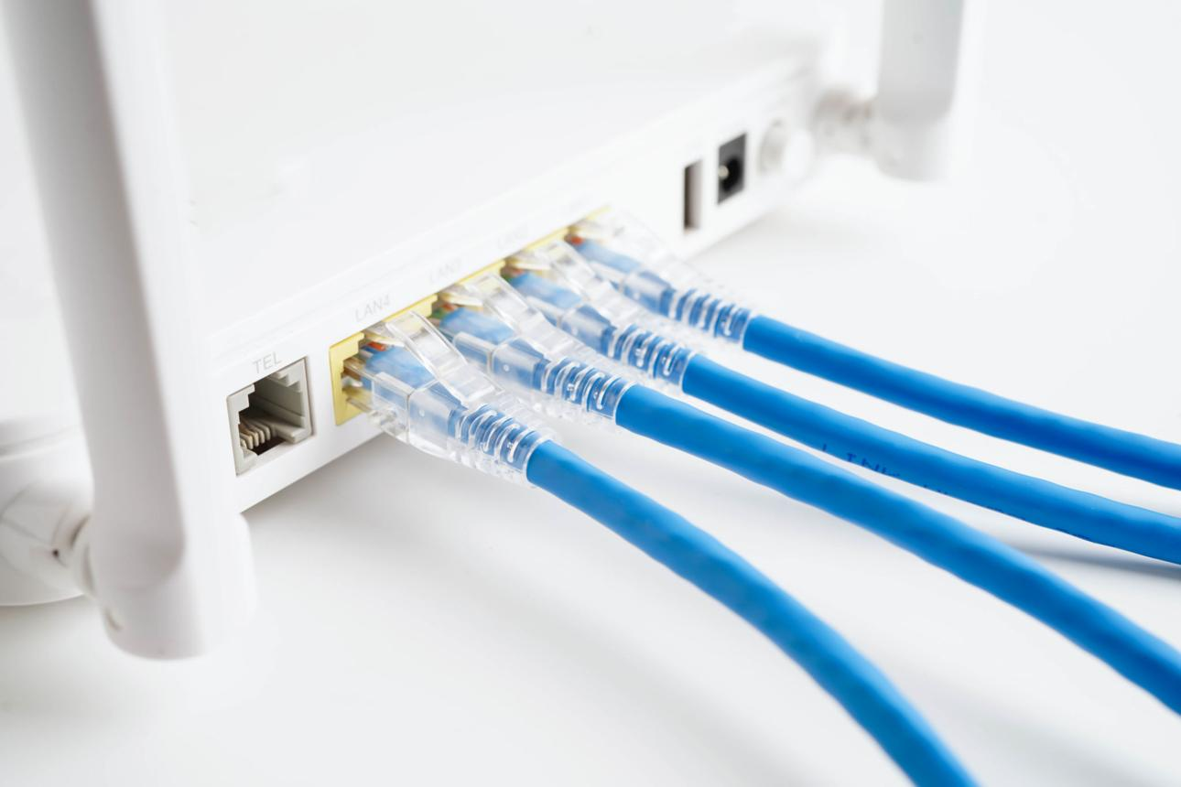
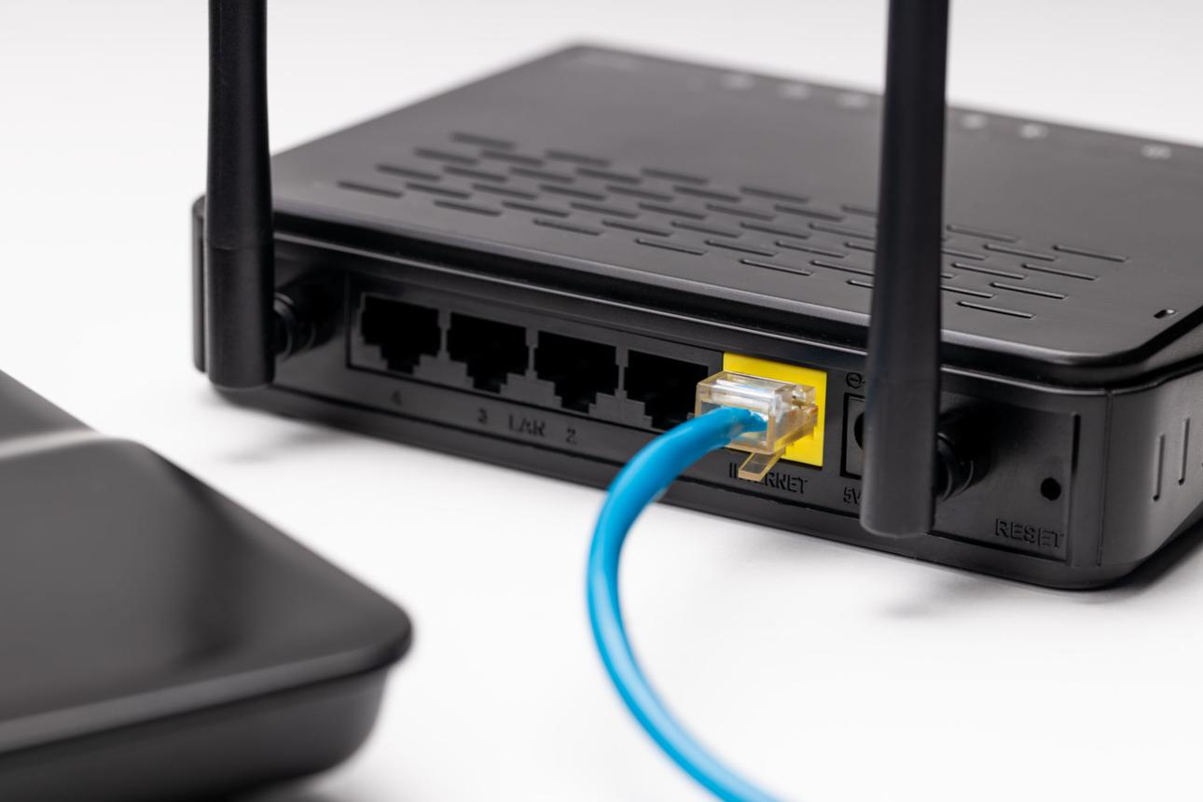
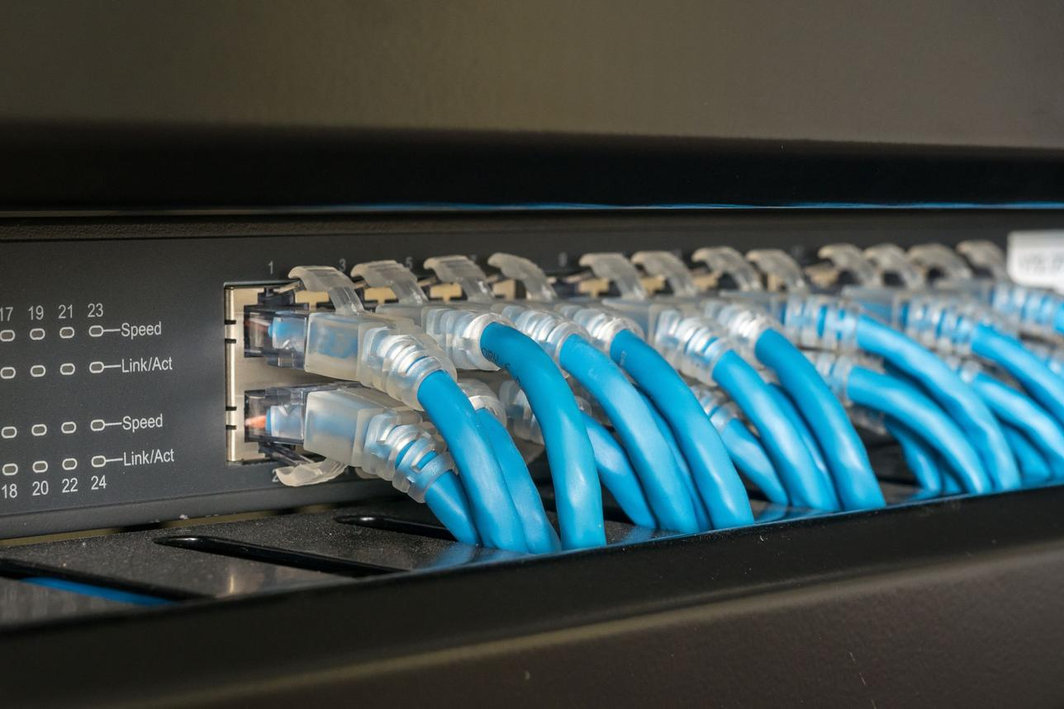
5
Example description for your assignment
Photo: Cat6 Ethernet cable connected to a Wi-Fi router/network switch.
Cable type: Cat6 Ethernet cable
Connector: RJ-45
Devices connected: The cable connects the router/switch to a computer, access point, or another network device.
Purpose: It provides a wired Ethernet connection for transferring network data between the devices. Compared with a wireless connection, a wired Ethernet link can provide a stable and predictable connection for suitable network equipment.
You can write this below your actual photo
Observation: The photograph shows a blue Cat6 Ethernet cable with RJ-45 connectors. One end is connected to the LAN/Ethernet port of a network device, while the other end is connected to a computer/switch. The cable is used to provide a wired network connection for data communication.
Note: If your actual cable says Cat5e, write Cat5e instead of Cat6. Check the printing on the cable jacket before submitting the assignment.

Quick Revision
Topic | Answer
T568B Pin 1 | White/Orange
T568B Pin 2 | Orange
T568B Pin 3 | White/Green
T568B Pin 4 | Blue
T568B Pin 5 | White/Blue
T568B Pin 6 | Green
T568B Pin 7 | White/Brown
T568B Pin 8 | Brown
Common copper connector | RJ-45
Recommended gaming-zone cable | Cat6
Long/high-speed backbone | Fiber optic
Cable tester purpose | Checks wire/pin continuity and order
Straight-through cable | Same standard on both ends, e.g. T568B–T568B

